

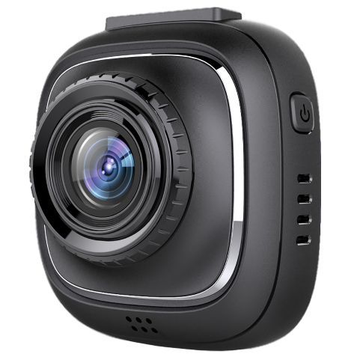

**F10**

**USER MANUAL**

The information in this manual is subject to change without notice.

www.rexingusa.com 11/2017

**Safety information**

To prevent injury to yourself or others, or damage to your device, read all safety information before using.

**Warning**

**Failure to comply with safety warnings and regulations can result in serious injury or death.**

***Rexing Dash Cam* is not intended to be touched, modified, or calibrated while operating a vehicle. *Rexing* is not responsible for any damages resulting from the user's misuse of the camera.**

**Do not use damaged power cords or plugs, or loose electrical sockets.** Faulty connections can cause electric shock or fire.

**Do not touch the car charger with wet hands or disconnect the charger by pulling the cord.** Doing so may result in electrocution.

**Do not use a bent or damaged car charger.** Doing so may cause electric shock or fire.

**Do not use your device while it is charging or touch your device with wet hands.** Doing so may cause electric shock.

**Do not short-circuit the charger or the device.** Doing so may cause electric shock or fire, or cause the battery to malfunction or explode.

**Use only manufacturer-approved chargers, accessories, and supplies.**

* Using generic chargers may shorten the life of your device or cause the device to malfunction. They may also cause fire or cause the battery to explode.
* Use only the manufacturer-approved charger specifically designed for your device. Using an incompatible charger can cause serious personal injury or damage to your device.
* ***Rexing*** cannot be responsible for the user’s safety when using accessories or supplies that are not approved by ***Rexing***.

**Do not drop the charger or device, or subject them to impact.** Handle and dispose of the charger and device with care.

* Never crush or puncture the device.
* Never dispose of the device in a fire.
* Never place the device in or on heating devices, such as microwave ovens, stoves, or radiators. The device may explode if overheated. Follow all local regulations when disposing of a used device.
* Avoid exposing the device to high external pressure, which can lead to an internal short circuit and overheating.

**Protect the device and charger from damage.**

* Avoid exposing your device to excessive cold or heat. Extreme temperatures can damage the device and reduce the charging capacity and life of your device.
* Do not allow children or animals to bite or chew the device. Doing so can result in fire or explosion, and small parts can be a choking hazard. If children use the device, make sure they use the device properly.
* Never use a damaged charger.

**Do not handle a damaged or leaking lithium ion (Li-Ion) battery.** For safe disposal of your Li-Ion battery, contact your nearest authorized service center.

**Caution**

**Failure to comply with safety precautions and regulations can result in property damage, serious injury or death.**

**Do not use your device near other electronic devices.** Most electronic devices use radio frequency signals. Your device may interfere with other nearby electronic devices.

**Do not use your device near other devices that emit radio signals, such as sound systems or radio towers.** Radio signals from these may cause your device to malfunction.

**Do not expose the device to heavy smoke or fumes.** Doing so may damage the outside of the device or cause it to malfunction.

**If you notice strange smells or sounds coming from your device, or if you see smoke or liquid leaking from the device, stop using the device immediately and take it to a *Rexing* Service Center.** Failure to do so may result in fire or explosion.

**For your own safety, do not operate the controls of this product while driving.** The window mount is needed when using the recorder in a car. Make sure that you place the recorder in a location where it will not obstruct the driver’s view.

**Always keep the camera lens clean, and ensure that the lens is not blocked by any object or placed near any reflective material.** If the car’s windshield is tinted with a dark coating, recording quality may be affected.

**Do not store your device in excessively hot, cold, damp or dry locations.** Doing so may cause the screen to malfunction, result in damage to the device, or cause the battery to explode. Your device is recommended for use within a temperature range of -10 °C to 70 °C, and a humidity range of 10% to 80%.

**If your device becomes overheated, allow it to cool down before use.** Prolonged exposure of skin to an overheated device may cause low-temperature burn symptoms, such as red spots or areas of darker pigmentation.

**Install mobile devices and equipment with caution.**

* Ensure that any mobile devices or related equipment installed in your vehicle are securely mounted.
* Avoid placing your device and accessories in or near an airbag deployment area. Improperly installed wired equipment can cause serious injury in a situation where airbags inflate rapidly.

**Do not drop your device or subject your device to impact.** If the device is bent, deformed or damaged, malfunction may occur.

**Take care to maximum battery and charger life:**

* Your device may wear out over time. Some parts and repairs are covered by the warranty within the validity period, but damage or deterioration related to the use of unapproved accessories is not.

**Do not attempt to disassemble, repair, or modify your device.**

* Any changes or modifications to your device can void your manufacturer’s warranty.

**Clean your device and charger by wiping with a towel or eraser.** Do not use chemicals or detergents. Doing so can discolor or corrode the outside of the device, and may result in electric shock or fire.

**Do not distribute copyright-protected material.** Doing so without the permission of the content owners may violate copyright laws. The manufacturer is not responsible or liable for any legal issues that result from the user’s illegal use of copyrighted material.

**Correct disposal of this product**

(applicable in countries with separate waste collection systems)



*Waste Electrical & Electronic Equipment*

This symbol, found on the device, accessories or accompanying literature, indicates that the product and its electronic accessories (e.g. charger, headset, USB cable) should not be disposed of with other household waste.

To prevent possible harm to the environment or human health from uncontrolled waste disposal, **please separate these items from other types of waste and recycle them responsibly** to promote the sustainable reuse of material resources.

Household users should contact either the retailer where they purchased this product, or their local government office, for information on where and how they can take these items for environmentally safe recycling.

Business users should contact their supplier and check the terms and conditions of the purchase contract. This product and its electronic accessories should not be mixed with other commercial wastes for disposal.

**Disclaimer**

Some content and services accessible through this device belong to third parties and are protected by copyright, patent, trademark and/or other intellectual property laws. Such content and services are provided solely for your personal non-commercial use.

You may not use any content or services in a manner that has not been authorized by the content owner or service provider. Without limiting the foregoing, unless expressly authorized by the applicable content owner or service provider, you may not modify, copy, republish, upload, post, transmit, translate, sell, create derivative works, exploit, or distribute in any manner or medium any content or services displayed through this device.

“THIRD PARTY CONTENT AND SERVICES ARE PROVIDED “AS IS.” REXING DOES NOT WARRANT CONTENT OR SERVICES SO PROVIDED, EITHER EXPRESSLY OR IMPLIEDLY, FOR ANY PURPOSE. REXING EXPRESSLY DISCLAIMS ANY IMPLIED WARRANTIES, INCLUDING BUT NOT LIMITED TO, WARRANTIES OF MERCHANTABILITY OR FITNESS FOR A PARTICULAR PURPOSE. REXING DOES NOT GUARANTEE THE ACCURACY, VALIDITY, TIMELINESS, LEGALITY, OR COMPLETENESS OF ANY CONTENT OR SERVICE MADE AVAILABLE THROUGH THIS DEVICE AND UNDER NO CIRCUMSTANCES, INCLUDING NEGLIGENCE, SHALL REXING BE LIABLE, WHETHER IN CONTRACT OR TORT, FOR ANY DIRECT, INDIRECT, INCIDENTAL, SPECIAL OR CONSEQUENTIAL DAMAGES, ATTORNEY FEES, EXPENSES, OR ANY OTHER DAMAGES ARISING OUT OF, OR IN CONNECTION WITH, ANY INFORMATION CONTAINED IN, OR AS A RESULT OF THE USE OF ANY CONTENT OR SERVICE BY YOU OR ANY THIRD PARTY, EVEN IF ADVISED OF THE POSSIBILITY OF SUCH DAMAGES.”

Third party services may be terminated or interrupted at any time, and ***Rexing*** makes no representation or warranty that any content or service will remain available for any period of time. Content and services are transmitted by third parties by means of networks and transmission facilities over which ***Rexing*** has no control. Without limiting the generality of this disclaimer, ***Rexing*** expressly disclaims any responsibility or liability for any interruption or suspension of any content or service made available through this device.

***Rexing*** is neither responsible nor liable for customer service related to the content and services. Any question or request for service relating to the content or services should be made directly to the respective content and service providers.

**About this manual**

This device provides high-quality digital recording using ***Rexing***’s high standards of design, construction and technological expertise. This user manual describes the device’s functions and features in detail.Please read this manual before using the device to ensure safe and proper use. Note that all descriptions included here are based on the device’s default settings.

* Images and screenshots may differ in appearance from the actual product. Content may differ from the final product or from software provided by service providers, and is subject to change without prior notice.
* For the latest version of this manual, refer to the ***Rexing*** website at *www.rexingusa.com*.
* Available features and additional services may vary by device and software.
* Applications and their functions may vary by country, region, or hardware specifications.
* ***Rexing*** is not liable for performance issues caused by applications from any provider other than ***Rexing***.
* ***Rexing*** is not liable for performance issues or incompatibilities caused by failure to install the device as stated in this manual. Attempting to customize the installation may cause the device or applications to work improperly, which may result in device malfunctions and data corruption or loss. These actions are violations of your ***Rexing*** agreement and will void your warranty.
* Default applications that come with the device are subject to updates and possible discontinuation of support without prior notice. If you have questions about an application provided with the device, contact an authorized ***Rexing*** Service Center.

Contents

PRODUCT SPECIFICATIONS 15

GETTING STARTED 16

Device Layout 16

Buttons 17

Status Icons 18

Package Contents 20

Installation 21

Charging the battery 22

Inserting the Memory Card 23

Removing the Memory Card 25

Formatting the Memory Card 25

Turning the Device On and Off 26

Basic Operation 27

Wi-Fi Function 27

VIDEO SETTINGS 28

Resolution 28

Loop Recording 29

WDR (Wide Dynamic Range) 29

Exposure 29

Motion Detection 30

Recording Audio 30

Date Stamp 30

Gravity Sensing 30

SYSTEM SETTINGS 31

WiFi 31

Date/ Time Setup 31

Auto Power Off 31

Beep Sound 31

Language 32

Frequency 32

Screen Saver 32

License No. Set 32

Format 33

Default Setting 33

Version 33

PHOTO SETTINGS 34

Capture Mode 34

Resolution 34

Sequence 34

Quality 34

Sharpness 35

White Balance 35

Color 35

ISO 35

Exposure 36

Anti-Shaking 36

Quick Review 36

Date Stamp 36

Updating Firmware 37

Playback Mode 38

Deleting Files 38

PC Playback Function 39

General Troubleshooting 40

# PRODUCT SPECIFICATIONS

|  |  |
| --- | --- |
| Image Sensor | 5MP CMOS |
| Lens | Fixed-focus with full-glass elements |
| Aperture | F = 2.8 |
| Audio | Built-in high-sensitivity microphone/speaker |
| External Memory | High endurance MicroSD Card (up to 32GB) |
| Gravity Sensor | Low / Medium / High / OFF |
| Shutter | Electronic |
| White Balance | Auto |
| Exposure | Auto ISO |
| TV Interface | None |
| Battery | 320mAh 3.7V rechargeable lithium ion battery |
| Video Format | MOV |
| Video Resolution | 1920x1080p30, 1280x720p30, 848x480p30, 640x480p30 |
| Time Lapse Recording | 100Ms, 200Ms, 500Ms, Off |
| Languages | English, Chinese, French, Spanish, Portuguese, German, Italian, Russian, Japanese |
| USB | USB 2.0 |
| Loop Recording | 3 min / 5 min / 10 min / OFF |
| Screen Saver | 15 Secs / 1 min / 3 min / OFF |
| Auto Shutdown | 3 min / 5 min / 10 min / OFF |
| Microphone Mute | ON / OFF |
| Wi-Fi | Yes |
| GPS | No |

# GETTING STARTED

## Device Layout

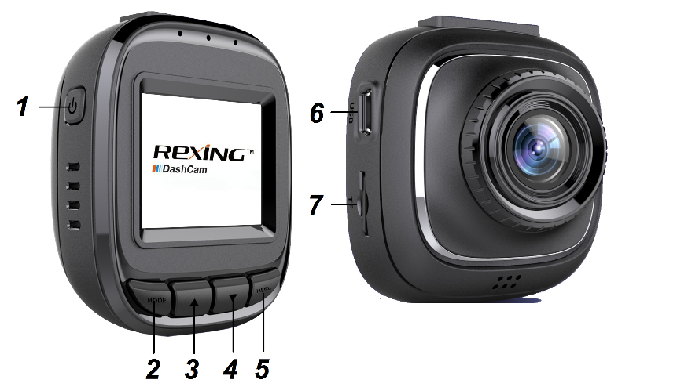

1. Power/OK Button
2. MODE Button
3. Up/Zoom In Button
4. Down/Zoom Out Button
5. MENU/WiFi Button
6. Mini USB Port
7. MicroSD Card Slot

## Buttons

|  |  |
| --- | --- |
| **Button** | **Functions** |
| **| OK** | * When in settings: Press to confirm a selection * Hold to turn the device on or off * Press to start / stop recording |
| **MODE** | * When not recording: Press to toggle between Recording / Photo / Playback modes * When recording: Emergency Lock (Press to manually lock the file during recording) |
| ▲ | * When in settings: Press to navigate UP * When recording: Press to zoom in |
| ▼ | * When in settings: Press to navigate DOWN * When recording: Press to zoom out |
| **MENU** | * When not recording: Press to enter and exit settings menu * When not recording: Hold to turn on Wi-Fi mode |

## Status Icons

|  |  |
| --- | --- |
| Icon | Meaning |
| **1080FHD** | Video Resolution |
| wdr | Wide Dynamic Range |
| charger | Charging via USB Charger |
| battery | Battery Power Level |
| mute | Microphone Mute |
|  | Microphone On |
| video | Video Recording Mode |
| playback | Video Playback Mode |
| photo | Photo Mode |
| loop | Loop Recording |
| memory | Memory Card Inserted |
| exp | White Balance |
|  | Current video file locked |

## Package Contents

Check the product box for the following items:

* F10 Dashboard Camera
* Suction Cup Mount
* Operating manual
* USB cable
* Car charger
* Thank you card

The items supplied with the device and any available accessories may vary depending on the region. Appearances and specifications are subject to change without prior notice. Availability of all accessories is subject to change depending entirely on manufacturing companies.

All supplied items are designed for use only with this device and may not be compatible with other devices. Malfunctions resulting from the use of unapproved accessories are not covered by the warranty service.

For more information about available accessories, refer to the ***Rexing*** website at *www.rexingusa.com*.

## Installation

Video guide: *video.rexingusa.com*

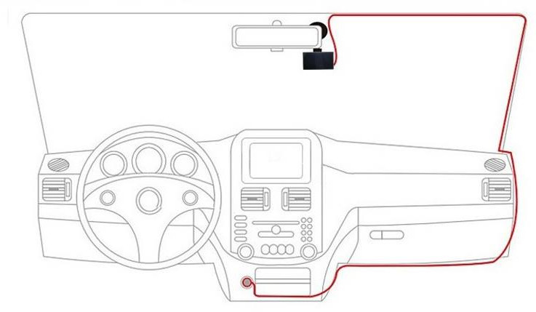

**1. Attaching the front camera to the window mount**

Before the device can be used in a car, it is essential to first install a properly attached window mount. Make sure that you place the recorder in a safe, appropriate location where it will not obstruct the driver’s view.

Clean windshield before apply mount.

**2 Inserting a memory card**

You will need to insert a memory card before you can begin recording. The recorder supports MicroSD cards with a capacity of up to 32GB. For reliable operation, use a high endurance MicroSD card with a capacity of at least 8GB.

**3. Connecting the charger to the car's 12V DC outlet**

Be sure to connect only the ***Rexing***-approved charger designed and supplied specifically for use with your device. Using an incompatible charger can cause serious personal injury or damage to your device.

**4. Format the memory card**

To ensure the memory card works on the dash cam, we highly recommend using the dash cam to format the memory card (See: Page 26).

**DO NOT** insert or remove a memory card while the device is powered on.

## Charging the battery

Charge the device by connecting the camera via the provided car charging adapter. Use only ***Rexing***-approved chargers. **Using unapproved chargers or cables can damage the device or cause the battery to explode.**

* Built-in battery is primarily used to save files in the event of an emergency. Please always connect the device to external power while it is in use.
* When the device detects no power supply, it will automatically power off after 5 seconds. To turn on the device again, you will need to do so manually by pressing the **Power/OK** button.
* If the battery is completely depleted, the device will not turn on immediately when the charger is connected. Allow a depleted battery to charge for a few minutes before attempting to turn on the device.
* The device can be used while it is charging, although it may take longer to fully charge the battery.
* If the device receives an unstable power supply while charging, the screen may not function properly. If this happens, unplug the charger from the device.
* While charging, the device may heat up. This is normal and should not affect the device’s performance or lifespan.
* If the device is not charging properly, take the device and the charger to an authorized ***Rexing*** Service Center or contact Customer Care.

**Connecting the charger improperly may cause serious damage to the device. Any damage caused by misuse is not covered by the warranty.**

## Inserting the Memory Card

Your device accepts memory cards with a maximum capacity of 32GB. Depending on the memory card manufacturer and type, some cards may not be compatible with your device. **Using an incompatible card may damage the device or the memory card, or corrupt the data stored on it.**

Recommended Card Type: High Endurance Micro SD Card

Use caution to insert the memory card right-side up as shown in the image (See: Page 24).

* Insert memory card with the gold-colored contacts facing upwards.
* Push the memory card into the slot until it locks in place.
* Click sound when memory card locks in place.
* Using a coin or other tool push memory card will make it easier.

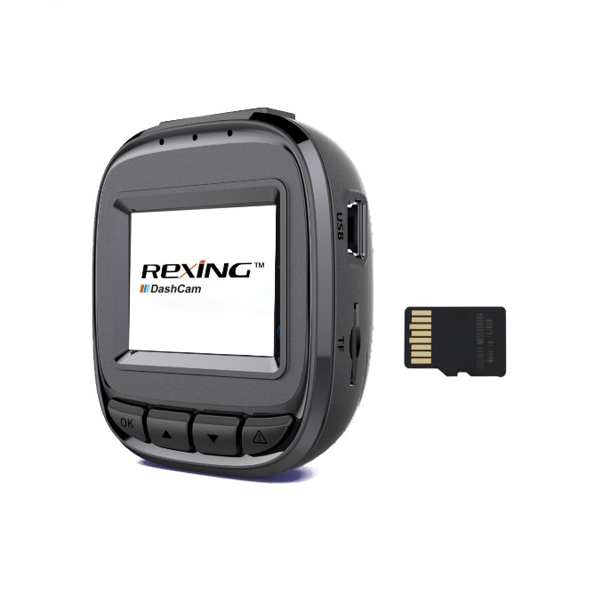

**It is recommended that you reformat a memory card after every time the images are transferred to a computer, or at least once a month.**

Reformatting a memory card keeps important elements of data and file structure clean, helping to prevent error messages and missing images. Reformatting also restores the memory card, which can help prevent it from becoming corrupted. For best results, format the memory card using the camera’s format function found in the settings menu (See: Page 26).

## Removing the Memory Card

Before removing a memory card from your computer, you must first prepare it for safe removal.

Before removing a memory card from your device:

1. Press the **Power/OK** button to stop the device from recording
2. Press and hold **Power/OK** button to power the device off.
3. Gently push the memory card in until you hear a click, and allow the spring release to push the card out.

**Do not remove the memory card while the device is transferring or accessing information.** Doing so can result in data loss or corruption, or damage to the memory card or device. ***Rexing*** is not responsible for losses that result from the use of damaged memory cards, including the loss of data.

## Formatting the Memory Card

Using the camera to format the memory card:

1. Press the **Power/OK** button to stop recording
2. Press the **MENU** button twice to enter the settings menu
3. Use the ▲ ▼ buttons to navigate down to the "Format" option
4. Press **Power/OK** to confirm your selection
5. Use the ▲ ▼ buttons to navigate to the “Yes” option
6. Press **Power/OK** when the word “Yes” is highlighted in blue

**Before formatting a memory card, always remember to make backup copies of all important data stored on the device.** The manufacturer’s warranty does not cover loss of data resulting from user actions.

## Turning the Device On and Off

Press and hold the **Power/OK** button for a few seconds to turn on the device. A welcome message will be displayed onscreen as shown in the image below.



To turn off the device, again press and hold the **Power/OK** button for a few seconds. A goodbye message will be displayed onscreen.



Note: The F10 Dashboard Camera will switch on and off automatically if you keep it permanently connected to the car charger. **If the car charging port provides a continuous flow of power, the camera will stay powered on at all times.**

## Basic Operation

* ***Rexing*** Dash Cam will atomically start recording once powered on.
* The red dot icon reddot on screen will be flashing while recording.
* During recording, press the **MODE** button to lock the current video clip, so the loop recording will not overwrite the clip. All locked video clip files can be found under \CARDV\MOVIE\RO within the memory card.

## Wi-Fi Function

Using your smart device (iPhone, Android, etc.), please download the “TimaCam” app from either the App Store or Google Play Store. After doing so, please follow the below instructions to connect your F10 to your smart device.



1. Press the **Power/OK** button to stop recording.
2. Hold **MENU** button to activate the Wi-Fi function.
3. Connect your device to the Wi-Fi SSID and input the required password as shown on the F10.
4. Open the TimaCam app on your device.
5. Follow the in-app instructions to interact with the F10.

To exit Wi-Fi function: Use the ▲ ▼ buttons to select the “WiFi_OFF” option and press the **Power/OK** button to return to Video Recording Mode.

# VIDEO SETTINGS

In Video Recording Mode, Press **Power/OK** to stop recording, then press **MENU** button once open the Video menu.

## Resolution

*Recommended setting: 1080FHD*

Use this setting to set the recording resolution.

Approximate recording time:

|  |  |  |
| --- | --- | --- |
| Memory card size | 1080p Resolution | 720p Resolution |
| 8GB | 1.3 hour | 2.4 hour |
| 16GB | 2.7 hour | 4.8 hour |
| 32GB | 5.3 hour | 10 hour |

## 

## Loop Recording

*Recommended setting: 3 Minutes*

With Loop Recording Mode enabled, the device will continuously erase older video as it records new video, keeping only the images captured over a user-selected time range. All video older than this range will be replaced with the newest video recorded. **Any locked video files on the memory card will remain protected, and will not be automatically deleted during Loop Recording.**

It is recommended that you format your memory card whenever you transfer files to your computer, or at least once a month. This keeps important elements of data and file structure clean, helping to prevent error messages and missing images. **Remember to always make backup copies of all important data stored on the device.** The manufacturer’s warranty does not cover loss of data resulting from user actions.

## WDR (Wide Dynamic Range)

*Recommended setting: On*

When enabled, this feature automatically adjusts exposure settings to improve recording quality in particularly bright or dim environments, providing balanced lighting and clearer video.

## Exposure

*Recommended setting: +0.0*

Allows you to adjust the camera exposure value to either brighten or darken your recordings.

## Motion Detection

*Recommended setting: Off*

Motion detection will record video when motion is detected by the device.

**Note: The device needs to be powered to use motion detection function.**

## Recording Audio

*Recommended setting: On*

Allows you to record audio with your video, or turn off the microphone so that all your recordings will be without audio.

## Date Stamp

Allows you to stamp the date and time to your recordings. This will display all the information about when the video was recorded at the bottom of the video.

## Gravity Sensing

*Recommended setting: Low*

This feature acts as an accelerometer, measuring physical and gravitational forces acting on the camera itself. If a change in these forces is detected, such as during a vehicular accident, the device will perform an automatic file lock, preserving your recording.

**Note:** Locked video files will **not** be erased during Loop Recording; they remain on the memory card until manually deleted, or when the card is reformatted.

# SYSTEM SETTINGS

In Video Recording Mode or Photo Mode, press **MENU** twice to open the Setup menu (in Video Recording Mode, you must first stop recording, done by pressing **Power/OK**).

## WiFi

Used to enable/disable Wi-Fi function (See: Page 27).

## Date/ Time Setup

Use this setting to change the device’s time and date.

▲ ▼ – Change value

**Power/OK** – Move to next segment

**MENU** – Save settings

**Note: If the battery remains fully discharged or is removed from the device, the time and date will be reset.**

## Auto Power Off

*Recommended setting: Off*

When enabled, this option allows the device to shut down automatically when Video Recording Mode is not active.

## Beep Sound

*Recommended setting: On*

This setting allows you to enable or disable the device's sound effects.

## Language

Use this setting to change the device’s language. Language availability may vary depending on the region.

## Frequency

*Recommended setting (for United States): 60Hz*

This option should be set according to the power supply specification used in your country or geographical region **(U.S. users should select the "60Hz" option)**.

## Screen Saver

*Recommended setting: 1 Minute*

Allows you to specify the duration for which the display will stay powered after recording starts.

## License No. Set

Enable this feature to enter your vehicle plate number. The plate number will be displayed at the bottom of all recorded video.

**To enter your license plate number:**

* **MENU** - Toggle selection between options
* ▲ ▼ – Cycle through letters/numbers
* **Power/OK** - Input your selected letter or number
* To delete a letter/number input, select “Del” option using **MENU**, and press **Power/OK** to delete the last letter/number input
* To confirm your license plate input, select “OK” and press **Power/OK**

## Format

Performing this operation will format the memory card.

**Note: All files in the memory card will be lost, including locked videos.**

## Default Setting

Performing this operation will reset all your device's settings to their original values.

Note: Any user-customized settings will be lost.

## Version

Allows you to see the device’s firmware version information.

# PHOTO SETTINGS

In Photo Mode, Press **MENU** once to open the Still Menu.

## Capture Mode

*Recommended setting: Single*

Allows you to set a timer that counts down before capturing images.

## Resolution

*Recommended setting: 5M*

This option allows you to set the pixel resolution for captured images.

## Sequence

*Recommended setting: Off*

When enabled, this feature allows you to capture a sequence of 3 quickly successive photos (typically known as burst mode).

## Quality

*Recommended setting: Normal*

This option allows you to set the quality level of captured images. Lower quality images will take up less space on the memory card.

## Sharpness

*Recommended setting: Normal*

This feature will automatically enhance captured images for a clearer, more distinct picture.

## White Balance

*Recommended setting: Auto*

This setting allows you to adjust the white balance for different lighting environments. When set to Auto, the device will automatically determine appropriate white balance for the video.

## Color

*Recommended setting: Normal*

This feature allows you to overlay a color effect for captured images. When set to Normal, no overlay is applied to your images.

## ISO

*Recommended setting: Auto*

This setting enables you to adjust the camera's sensitivity to light when taking photos. The higher the ISO, the better the camera makes out images in low light, but it will also make the images more noisy (grainy-looking).

## Exposure

*Recommended setting: +0.0*

Allows you to adjust the camera exposure value to either brighten or darken your images.

## Anti-Shaking

*Recommended setting: Off*

This feature enables the image stabilizer function to reduce blurring of captured images.

## Quick Review

*Recommended setting: Off*

Enabling this feature will allow you to immediately view each captured image for a few seconds before taking the next photo.

## Date Stamp

*Recommended setting: Date/Time*

This feature will automatically apply a date and/or time stamp to captured images (works similarly to the Date Stamp function in the Video menu).

# Updating Firmware

After locating the appropriate firmware from the ***Rexing*** website, follow these instructions to update the firmware for your F10 Dashboard Camera.

1. Download the firmware file to your computer
2. Unzip the file
3. Format your memory card
4. Copy the firmware files to the root of your card (not within any folders)
5. Insert card into camera after safely ejecting from your computer
6. Power camera on while the camera is plugged in
7. The camera will update automatically. The screen will stay off but the status light will stay on. This operation may take up to 1 minute to complete
8. After updating, you must format the memory card. Failure to do this will result in the unit attempting to update the firmware every time it’s turned on
9. **(Do not disconnect the unit from power)** Hold the power button to reboot
10. Upon reboot, you may disconnect your unit from power
11. Enjoy your updated device!

# Playback Mode

**To play back recorded video on your device:**

1. Press **Power/OK** to stop recording in Video Recording Mode
2. Press **MODE** twice to switch from Video Recording Mode to Playback Mode
3. Use the ▲ ▼ buttons to navigate through your recordings
4. Press **Power/OK** to play back a selected recording
5. Press **Power/OK** during playback to pause playback
6. Press **MODE** to stop playback
7. **FAST FORWARD**: During playback, press the ▲ button one or more times to set fast playback speed (2X / 4X / 8X)
8. **FAST REWIND**: During playback, press the ▼ button one or more times to set reverse playback speed (-2X / -4X / -8X)

## Deleting Files

**To delete a selected recording:**

1. Use the ▲ ▼ buttons to navigate through your recordings
2. Press **MENU** to view the following options for the selected recording: Delete/Protect/Slide Show
3. Press the ▼ button once to select "Delete"
4. Press **Power/OK** once to view options to "Delete Current" recording or "Delete All" recordings
5. With “Delete Current” selected, press **Power/OK**
6. When prompted with “Erase This?” press the ▼ button once to select "OK" and press **Power/OK** to delete the recording

**To delete all recordings:**

1. Use the ▲ ▼ buttons to navigate through your recordings
2. Press **MENU** to view the following options for the selected recording: Delete/Protect/Slide Show
3. Press the ▼ button once to select "Delete"
4. Press **Power/OK** once to view options to "Delete Current" recording or "Delete All" recordings
5. With “Delete All” selected, press **Power/OK**
6. When prompted with “Erase All Images?” press the ▼ button once to select "OK" and press **Power/OK** to delete all recordings

## PC Playback Function

**Minimum System Requirements**

*Windows Media Player* **OR** *QuickTime Media Player* **OR** any media player compatible with .MOV files

**Accessing Video Files**

Insert the SD card into your computer, or plug your camera into the computer USB port and select “Mass Storage” to access the video files.

# General Troubleshooting

|  |  |  |
| --- | --- | --- |
| **Problem** | **Possible Cause** | **Solution** |
| Images are not stored in memory card | Memory card may be full or malfunctioning  Image isn’t being saved before the device is powered off | Reformat memory card or replace with a new one  Make sure to stop recording before shutting down |
| None of the buttons are responding | Processing error or faulty device operation  Memory card may be malfunctioning | Reformat memory card or replace with a new card.  Press the buttons firmly, or hold them in, they may not respond to light taps. |
| **MENU** button isn’t responding | Unit may be recording | Press **Power/OK** to stop recording so you can access the menu. |
| Not holding charge  Keeps rebooting  Won’t turn on | Battery may be depleted  Power cord may be defective | Charge the battery for 3 hours, making sure the unit is off while charging  Turn on the unit and unplug it; if it turns off immediately, contact customer service for assistance with a replacement |
| SD Card won’t stay inside the unit | SD card may not be compatible  SD card may be too thin | Use your nail or a coin to push the SD Card in until it clicks  Use a different SD Card |
| SD Card isn’t recognized (custer error) | SD Card needs to be formatted | Format your SD Card  Use a different SD Card |
| Can’t find locked files | May have saved to the RO folder  When you lock a file, it only saves the current recording, so the remainder of the video may be in a separate file | Check the SD Card RO folder on your computer |
| Screen powers down unexpectedly | Screen Saver feature is enabled  Low battery | Disable the Screen Saver feature  Charge the battery  Restore default settings |
| Unit powers down unexpectedly | SD Card may not be compatible  Might not be getting continuous power | Use a different SD Card  Restore default settings  Get a replacement power cord |
| Unable to record videos | Memory card may be full  Memory card may be corrupted | Check remaining space on memory card and delete files if necessary  Reformat your memory card; if the issue persists, replace your card with a new one  Restore default settings |
| Stops recording after 20-40 minutes | Loop Recording off | Turn Loop Recording on |
| Stops recording at random intervals | SD Card is not Compatible | Use a different SD Card  Restore default settings |
| Loop Recording isn’t functioning | Gravity Sensing may be set too high  SD Card is full | Set Gravity Sensing to low or off in Video menu  Format SD Card |
| Stops recording after 1-3 looped videos | SD Card may not be compatible | Restore default settings  Use a different SD Card  Replace power cord |
| “File error" is encountered when trying to play back pictures or video | Memory card may be corrupted | Format the memory card |
| Images are hazy | Lens may be dirty | Carefully clean dust or fingerprints from the lens with a microfiber cloth |
| Horizontal stripes appear on images | The Light Frequency setting is incorrect | Change Light Frequency setting to match the power supply used in your country or geographical location (US users should select the 60Hz option, SG/MY users should select the 50hz option) |
| Auto On/Off function isn’t working | Car charging port has continuous flow of power | This feature can only work if it is being used in a charging port that turns off with the vehicle |
| Device is constantly resetting date/time | Firmware is out-of-date | Update your device firmware |